22.43: a) The sphere acts as a point charge on an external charge, so:
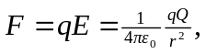 radially inward.

(b) If the point charge was inside the sphere (where there is no electric field) it would feel zero force.

